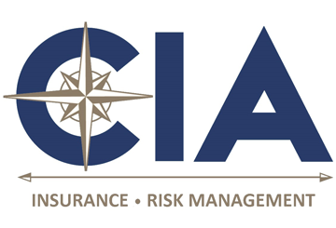
DOL Issues Model Notices, FAQs for COBRA Subsidy in the ARPA
Important Dates

March 11, 2021
ARPA signed into law.
April 1, 2021
ARPA subsidy for COBRA premiums began.
Sept. 30, 2021
ARPA subsidy for COBRA premiums expires.

On April 7, 2021, the U.S. Department of Labor (DOL) issued FAQs and model notices for the COBRA premium assistance provisions of the American Rescue Plan Act (ARPA). The ARPA provides a 100% subsidy for employer-sponsored group health insurance continued under COBRA and similar state continuation of coverage programs for eligible individuals. The subsidy applies from April 1 through Sept. 30, 2021. The notices and the FAQs appear on a new DOL webpage dedicated to the ARPA COBRA subsidy.
Model Notices
The new model notices released by the DOL are the following:
- Model General Notice and COBRA Continuation Coverage Election Notice: MS Word | PDF
- Model Notice in Connection with Extended Election Period: MS Word | PDF
- Model Alternative Notice: MS Word | PDF
- Model Notice of Expiration of Premium Assistance: MS Word | PDF
- Summary of COBRA Premium Assistance Provisions under the American Rescue Plan Act of 2021: MS Word | PDF
FAQs
Plans may use the DOL model notices to meet their notice obligations under the COBRA subsidy provisions of the ARPA.
Provided to you by CIA Insurance & Risk Management
The DOL guidance contains 21 FAQs on topics such as eligibility, elections, notice requirements and duration of the subsidy. Notably, the FAQs state that prior federal COVID-19-related relief for plan deadlines does not apply to notice or election periods set forth in the ARPA provisions about the COBRA subsidy. However, an individual may elect COBRA from an earlier qualifying event if the individual is eligible to make that election, including under the extended time frames provided under that relief.
.

